
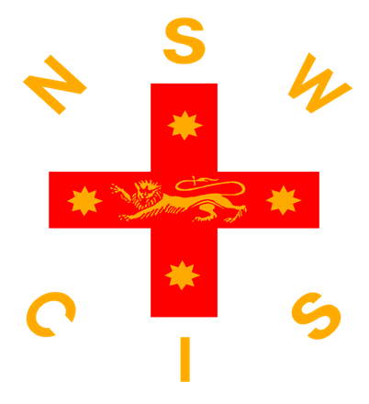

2026 19&U Boys Hockey Draw
TEAMS | COLOURS
AICES | Royal Blue, White and Gold
CSSA | White, Sky Blue and Navy Blue
NCIS (including CAS, GPS & RAS) | Royal Blue, Orange and White
ISA | Black, White and Gold

8.00am - FACILITY OPEN FOR WARM-UPS
TIME | MATCH  NUMBER | TEAM A | VS | TEAM B
8:30am | GK TRIAL
9.05am | 1 | AICES | VS | CSSA
10.05am | 2 | ISA | VS | NCIS
 | BREAK
11.15am | 3 | NCIS | VS | AICES
12:15pm | 4 | CSSA | VS | ISA
 | BREAK
1.25pm | 5 | ISA | VS | AICES
2.25pm | 6 | NCIS | VS | CSSA
3.30pm | MEDAL PRESENTATION & ANNOUNCEMENT OF NSWCIS TEAM

2026 15&U Boys Hockey Draw
2 x 12 minute halves
TIME | TEAM | VS | TEAM
9:00AM | Blue | VS | Green
9:30AM | Red | VS | Yellow
10:00AM | Blue | VS | White
10:30AM | Green | VS | Red
11:00AM | FIELD WATERING
11:10AM | Blue | VS | Yellow
11:40AM | Green | VS | White
12:10PM | Blue | VS | Red
12:40PM | Yellow | VS | White
1:10PM | GOALKEEPER TRIAL
1:40PM | Red | VS | White
2:10PM | Green | VS | Yellow
2:40PM | POSSIBLES V PROBABLES
3:25PM | CIS TEAM ANNOUNCEMENT

2026 Secondary Girls 15&U Hockey Draw

TEAMS | COLOURS
AICES | Royal Blue, White and Gold
IGSA | Black, Pink and White
CSSA | White, Sky Blue and Navy Blue
ISA | Black, White and Gold
NCIS | Royal Blue, Orange and White

2x12 minute halves, 3 minute half time, 2 minutes between games

8.00am - FACILITY OPEN FOR WARM-UPS
TIME | FIELD NUMBER | TEAM A | VS | TEAM B
9.00am | 1 | ISA | VS | AICES
9.30am | 1 | IGSA | VS | NCIS
10.00am | 1 | ISA | VS | CSSA
10.30am | 1 | AICES | VS | NCIS
11:00am | GOAL-KEEPER TRIALS
11:30am | 1 | CSSA | VS | IGSA
12:00pm | 1 | ISA | VS | NCIS
12:30pm | 1 | AICES | VS | CSSA
1:00pm | 1 | IGSA | VS | ISA
1:30pm | 1 | CSSA | VS | NCIS
2:00pm | 1 | IGSA | VS | AICES
2:30pm | SELECTORS MEETING
2:45pm | MEDAL PRESENTATION TO CHAMPION ASSOCIATION
3:00pm | 1 | POSSIBLES | VS | PROBABLES
3:3cis.nsw.edu.au0pm | ANNOUNCEMENT OF NSWCIS TEAM

2026 Secondary Girls 19&U Hockey Draw

TEAMS | COLOURS
AICES | Royal Blue, White and Gold
CSSA (includes NCIS & RAS) | White, Sky Blue and Navy Blue
IGSA | Black, Pink and White
ISA + Rotating GK | Black, White and Gold

12 minute quarters, 5 minute Half Time, 2 Minute Quarter time

8.00am - FACILITY OPEN FOR WARM-UPS
TIME | FIELD NUMBER | TEAM A | VS | TEAM B
9.00am | 1 | IGSA | VS | ISA
9:00am | 3 | CSSA | VS | AICES
10:00am | BREAK & GOAL KEEPER TRIALS
10:30am | 1 | ISA | VS | CSSA
10:30am | 3 | AICES | VS | IGSA
11:30am | BREAK
12:00pm | 1 | CSSA | VS | IGSA
12:00pm | 1 | AICES | VS | ISA
1:00pm | SELECTORS MEETING
1:15pm | MEDAL PRESENTATION TO CHAMPION ASSOCIATION
1:30pm | 1 | POSSIBLES | VS | PROBABLES
2:15pm | ANNOUNCEMENT OF NSWCIS TEAM

15/04/2026 CIS SECONDARY HOCKEY PARTICIPATION
CLOSE 21 APRIL (15s) 22 APRIL (19s)
 | 15s Boys | 15s Girls | 19s Boys | 19s Girls
AICES | 29  (+ 4 pending) | Team | Team | Team
CAS | 4  (+2 pending) |  | (+1 pending)
CSSA | 8  (+9 pending) | Team (16)  inc 2 GKs | Team (11)  inc 1 GK | Team (13)  inc 2 GKs
GPS | 3 |  | 2 players registered
IGSA |  | Team |  | Team
ISA | 9  (+3 pending) | Team | Team | Team  (No GK)
NCIS | 4 | 10 players  Coach, Manager  Uniforms | 6 Players  Coach  Uniform | 3 players  Manager
RAS | NIL | Team  (No GK) | 1 player | 1 player
STUDENT OFFICIALS
 | Max Brown | Calrossy

