
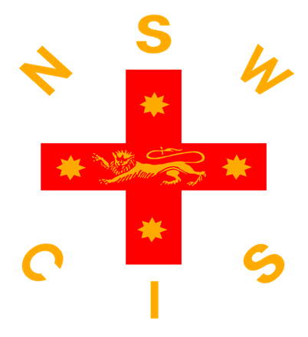

2026 15&U Boys Hockey Draw
2 x 12 minute halves
TIME | TEAM | VS | TEAM
9:00AM | Blue | VS | Green
9:30AM | Red | VS | Yellow
10:00AM | Blue | VS | White
10:30AM | Green | VS | Red
11:00AM | FIELD WATERING
11:10AM | Blue | VS | Yellow
11:40AM | Green | VS | White
12:10PM | Blue | VS | Red
12:40PM | Yellow | VS | White
1:10PM | GOALKEEPER TRIAL
1:40PM | Red | VS | White
2:10PM | Green | VS | Yellow
2:40PM | POSSIBLES V PROBABLES
3:25PM | CIS TEAM ANNOUNCEMENT

2026 19&U Boys Hockey Draw
TEAMS | COLOURS
AICES | Royal Blue, White and Gold
CSSA | White, Sky Blue and Navy Blue
NCIS (including CAS, GPS & RAS) | Royal Blue, Orange and White
ISA | Black, White and Gold

8.00am - FACILITY OPEN FOR WARM-UPS
TIME | MATCH  NUMBER | TEAM A | VS | TEAM B
8:30am | GK TRIAL
9.05am | 1 | AICES | VS | CSSA
10.05am | 2 | ISA | VS | NCIS
 | BREAK
11.15am | 3 | NCIS | VS | AICES
12:15pm | 4 | CSSA | VS | ISA
 | BREAK
1.25pm | 5 | ISA | VS | AICES
25pm | 6 | NCIS | VS | CSSA
3.30pm | MEDAL PRESENTATION & ANNOUNCEMENT OF NSWCIS TEAM

2026 Secondary Girls 15&U Hockey Draw

TEAMS | COLOURS
AICES | Royal Blue, White and Gold
IGSA | Black, Pink and White
CSSA | White, Sky Blue and Navy Blue
ISA | Black, White and Gold
NCIS | Royal Blue, Orange and White

2x12 minute halves, 3 minute half time, 2 minutes between games

8.00am - FACILITY OPEN FOR WARM-UPS
TIME | FIELD NUMBER | TEAM A | VS | TEAM B
8.30am | 1 | ISA | VS | AICES
8:55am | 1 | RAS | VS | CSSA
9.20am | 1 | IGSA | VS | NCIS
9.45am | 1 | ISA | VS | CSSA
10:10am | 1 | RAS | VS | IGSA
10:35am | 1 | AICES | VS | NCIS
11:00am | GOALKEEPER TRIALS & WATER THE PITCH
11:30am | 1 | CSSA | VS | IGSA
11:55am | 1 | RAS | VS | AICES
12.20pm | 1 | ISA | VS | NCIS
12:45pm | 1 | AICES | VS | CSSA
1:10pm | 1 | NCIS | VS | RAS
1:35pm | 1 | IGSA | VS | ISA
2:00pm | 1 | CSSA | VS | NCIS
2:25pm | 1 | ISA | VS | RAS
2:50pm | 1 | IGSA | VS | AICES
3:15pm | SELECTORS MEETING
3:25pm | MEDAL PRESENTATION TO CHAMPION ASSOCIATION
3:35pm | 1 | POSSIBLES | VS | PROBABLES
4:00pm | ANNOUNCEMENT OF CIS TEAM

2026 Secondary Girls 19&U Hockey Draw

TEAMS | COLOURS
AICES | Royal Blue, White and Gold
CSSA (includes NCIS & RAS) | White, Sky Blue and Navy Blue
IGSA | Black, Pink and White
ISA + Rotating GK | Black, White and Gold

12 minute quarters, 5 minute Half Time, 2 Minute Quarter time

8.00am - FACILITY OPEN FOR WARM-UPS
TIME | FIELD NUMBER | TEAM A | VS | TEAM B
9.00am | 1 | IGSA | VS | ISA
9:00am | 3 | CSSA | VS | AICES
10:00am | BREAK & GOAL KEEPER TRIALS
10:30am | 1 | ISA | VS | CSSA
10:30am | 3 | AICES | VS | IGSA
11:30am | BREAK
12:00pm | 1 | CSSA | VS | IGSA
12:00pm | 1 | AICES | VS | ISA
1:00pm | SELECTORS MEETING
1:15pm | MEDAL PRESENTATION TO CHAMPION ASSOCIATION
1:30pm | 1 | POSSIBLES | VS | PROBABLES
2:15pm | ANNOUNCEMENT OF NSWCIS TEAM

