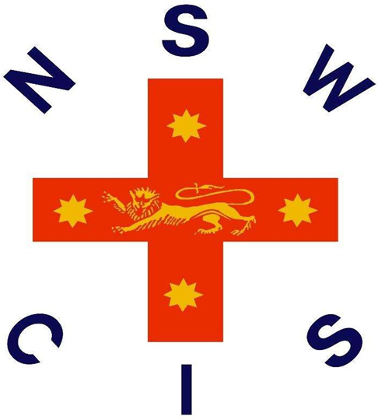
t

2026 NSWCIS
Secondary Boys 15 Years and Under Touch Trials 2026

Selection Championships
1st May, 2026
Kingsway Touch Fields, The Kingsway, Werrington NSW 2747, Australia

Welcome

On behalf of NSWCIS, we welcome students, parents, officials and staff to the Secondary Boys 15 Years and Under Touch Trials 2026. Congratulations to every student who is participating today on being selected to represent your school and association.

NSWCIS aims to provide a pathway to state and national level competition. Many CIS athletes have continued through this pathway, leading to higher competition, some as high as the Commonwealth and Olympic Games.

Thank you to all of those involved in making the event possible, and we look forward to positive and successful trial.

Acknowledgement of Country

In the spirit of reconciliation, NSWCIS acknowledges the Traditional Custodians of country throughout Australia and their connections to land, sea and community. We pay our respect to their Elders past and present and extend that respect to all Aboriginal and Torres Strait Islander peoples today.

Secondary Boys 15 Years and Under Touch Trials 2026 Overview

Convenor and Team Manager:

Convenor: Yass Sidaros | The Hills Grammar School | AICES

Coach: James Blackwood | Knox Grammar School | CAS

Ass. Coach: Tom Taylor | Newcastle Grammar School | AICES

Manager: Jake Cassell | Kesser Torah College | AICES

NSW State Championships: Wednesday 26th August - Thursday 27th August 2026

Secondary Boys 15 Years and Under Touch Trials 2026 Information

Date: 1st May, 2026
Venue: Kingsway Touch Fields, The Kingsway, Werrington NSW 2747, Australia
Registration: From 7:30am
Event Start Time: 8:30am
Event Finish Time: 2:30pm
Event Overview: The Championships will occur as a Round Robin in Association Teams. Possibles v Probables matches may follow if required. At the conclusion, up to 14 players will be selected into the CIS 15&U Boys Touch Football Team. The team will be announced and available to view on the Touch Football Sport page of the CIS website by 6pm on Friday evening.
What to Bring: Students are encourage to bring all snacks and lunch, along with plenty of water. Canteen facilities will be available.
What to Wear: All triallists must wear their Association uniform.
N.B. Football Boots with screw in studs are not permitted.

General Information

Selection Note: Selections are based on the performance of all students on the day.
Areas of performance considered:
- Skills exhibited by the player;
- Fitness level exhibited by the player;
- Performance of the player as a member of a team;
- Attitude and behaviour of player both on and off the court/field;

Code of Conduct
- CIS Athletes Code of Conduct
- CIS Officials Code of Conduct
- CIS Spectators Code of Conduct

CIS Team
There will be a player’s levy and mandatory uniform costs associated with competing at the next level. Triallists should ensure they are available to the NSW State Championships if selected.

1. Nomination | An email has been sent to the parent of any students nominated for a NSWCIS trial. This email will contain information about the event as well as a link to finalise the nomination.
2. Click the Link | Click the link supplied in this email. If you already have a Dash account, this link should automatically log you in to your account, direct you to your application and ask you to select your child.  If you have a Dash account but the child has not yet been added, click “Add another child”.  If you do not yet have a Dash account, go to step 3.
3. Register | If you do not yet have a Dash account, the link you click in the above email will take you to a page which asks you to “Login” or “Register Now”. Click “Register Now” and follow the prompts to create your account.
4. Add your Child | Once you have created an account you will be required to add your child to your account. Follow the prompts to create your child, including selecting their school and uploading any necessary medical information. This only needs to be done once per child.
5. Create Application | Once you have completed the above steps you should be free to finalise the application via the “Create Application” button.  If you have followed steps 3 and 4 and are no longer on the application screen, you can repeat step 2, or click the link supplied in the blue banner at the top of your Dash account.
Application Process

If you are experiencing any technical difficulty processing your application, please contact support@dashapp.com.au.

NSWCIS Merchandise Range
Students who are selected to represent their School and/or Association at a CIS Event are eligible to purchase CIS Merchandise. All merchandise is available online and will be posted to your nominated shipping address. Click the icon below to shop.

