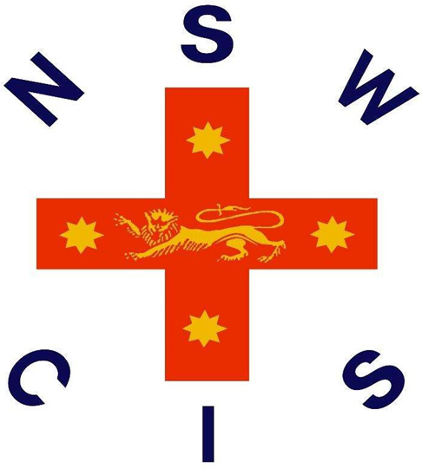

2026 NSWCIS
NSWCIS Secondary Boys 19&U Volleyball Trial

Selection Championships
2nd April, 2026
Sydney Grammar School, 10 College St, Darlinghurst NSW 2010, Australia

Welcome

On behalf of NSWCIS, we welcome students, parents, officials and staff to the NSWCIS Secondary Boys 19&U Volleyball Trial. Congratulations to every student who is participating today on being selected to represent your school and association.

NSWCIS aims to provide a pathway to state and national level competition. Many CIS athletes have continued through this pathway, leading to higher competition, some as high as the Commonwealth and Olympic Games.

Thank you to all of those involved in making the event possible, and we look forward to positive and successful trial.

Acknowledgement of Country

In the spirit of reconciliation, NSWCIS acknowledges the Traditional Custodians of country throughout Australia and their connections to land, sea and community. We pay our respect to their Elders past and present and extend that respect to all Aboriginal and Torres Strait Islander peoples today.

NSWCIS Secondary Boys 19&U Volleyball Trial Overview

Convenor and Team Manager:

Convenor: Colin Lai | Redfield College | AICES

Coach: Seth Chen | Sydney Grammar School | GPS

Manager: Luke Grant | Knox Grammar School | CAS

NSW State Championships: Friday 1st May 2026 at Netball Central, Sydney Olympic Park

NSWCIS Secondary Boys 19&U Volleyball Trial Information

Date: 2nd April, 2026
Venue: Sydney Grammar School, 10 College St, Darlinghurst NSW 2010, Australia
Registration: Register from 1pm
Event Start Time: 1:30pm
Event Finish Time: 3:30pm
Event Overview: The trial format is individual involving game skills, drills and match play. At the conclusion of the trials, up to 12 boys will be named in the 2026 CIS Secondary 19&U Boys Team to compete at the NSW All Volleyball Tri-Series. The team list will be announced at the event and will be available to view on the CIS website the following day.
What to Bring: Please bring snacks, along with plenty of water as there will be no opportunity to purchase food or drink at the venue.
What to Wear: All triallists should wear their Association or School Sports uniform. No State or Representative uniform should be worn.

General Information

Selection Note: Selections are based on the performance of all students on the day.
Areas of performance considered:
- Skills exhibited by the player;
- Fitness level exhibited by the player;
- Performance of the player as a member of a team;
- Attitude and behaviour of player both on and off the court/field;

Code of Conduct
- CIS Athletes Code of Conduct
- CIS Officials Code of Conduct
- CIS Spectators Code of Conduct

CIS Team
There will be a player’s levy and mandatory uniform costs associated with competing at the next level. Triallists should ensure they are available to the NSW State Championships if selected.

1. Nomination | An email has been sent to the parent of any students nominated for a NSWCIS trial. This email will contain information about the event as well as a link to finalise the nomination.
2. Click the Link | Click the link supplied in this email. If you already have a Dash account, this link should automatically log you in to your account, direct you to your application and ask you to select your child.  If you have a Dash account but the child has not yet been added, click “Add another child”.  If you do not yet have a Dash account, go to step 3.
3. Register | If you do not yet have a Dash account, the link you click in the above email will take you to a page which asks you to “Login” or “Register Now”. Click “Register Now” and follow the prompts to create your account.
4. Add your Child | Once you have created an account you will be required to add your child to your account. Follow the prompts to create your child, including selecting their school and uploading any necessary medical information. This only needs to be done once per child.
5. Create Application | Once you have completed the above steps you should be free to finalise the application via the “Create Application” button.  If you have followed steps 3 and 4 and are no longer on the application screen, you can repeat step 2, or click the link supplied in the blue banner at the top of your Dash account.
Application Process

If you are experiencing any technical difficulty processing your application, please contact support@dashapp.com.au.

NSWCIS Merchandise Range
Students who are selected to represent their School and/or Association at a CIS Event are eligible to purchase CIS Merchandise. All merchandise is available online and will be posted to your nominated shipping address. Click the icon below to shop.

